APPENDIX E

SOLUTIONS TO PROBLEMS

E.1 This follows directly from partitioned matrix multiplication in Appendix D. Write

X = 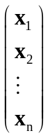, X′ = (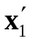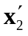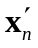), and y = 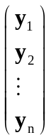

Therefore, X′X = 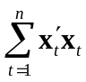 and X′y = 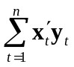. An equivalent expression for is
= 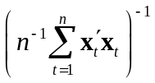 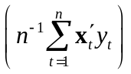
which, when we plug in y_{t} = x_{t}β + u_{t} for each t and do some algebra, can be written as
= β + 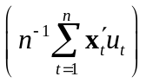.
As shown in Section E.4, this expression is the basis for the asymptotic analysis of OLS using matrices.

E.2 (i) Following the hint, we have SSR(b) = (y – Xb)′(y – Xb) = [ + X( – b)]′[ + X( – b)] = ′ + ′X( – b) + ( – b)′X′ + ( – b)′X′X( – b). But by the first order conditions for OLS, X′ = 0, and so (X′)′ = ′X = 0. But then SSR(b) = ′ + ( – b)′X′X( – b), which is what we wanted to show.

(ii) If X has a rank k then X′X is positive definite, which implies that ( – b) ′X′X( – b) > 0 for all b ≠ . The term ′ does not depend on b, and so SSR(b) – SSR() = (– b) ′X′X (– b) > 0 for b ≠.

E.3 (i) We use the placeholder feature of the OLS formulas. By definition, = (Z′Z)⁻¹Z′y = [(XA)′ (XA)]⁻¹(XA)′y = [A′(X′X)A]⁻¹A′X′y = A⁻¹(X′X)⁻¹(A′)⁻¹A′X′y = A⁻¹(X′X)⁻¹X′y = A⁻¹.

(ii) By definition of the fitted values, 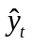 = 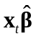 and 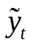 = 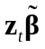. Plugging z_{t} and into the second equation gives = (x_{t}A)(A⁻¹) = = .

(iii) The estimated variance matrix from the regression of y and Z is 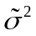(Z′Z)⁻¹ where is the error variance estimate from this regression. From part (ii), the fitted values from the two regressions are the same, which means the residuals must be the same for all t. (The dependent variable is the same in both regressions.) Therefore, = 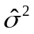. Further, as we showed in part (i), (Z′Z)⁻¹ = A⁻¹(X′X)⁻¹(A′)⁻¹, and so (Z′Z)⁻¹ = A⁻¹(X′X)⁻¹(A⁻¹)′, which is what we wanted to show.

(iv) The 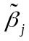 are obtained from a regression of y on XA, where A is the k × k diagonal matrix with 1, a₂, , a_{k} down the diagonal. From part (i), = A⁻¹. But A⁻¹ is easily seen to be the k × k diagonal matrix with 1, 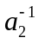, , 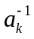 down its diagonal. Straightforward multiplication shows that the first element of A⁻¹ is 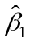 and the j^{th} element is 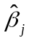/a_{j}, j = 2, , k.

(v) From part (iii), the estimated variance matrix of is A⁻¹(X′X)⁻¹(A⁻¹)′. But A⁻¹ is a symmetric, diagonal matrix, as described above. The estimated variance of is the j^{th} diagonal element of A⁻¹(X′X)⁻¹A⁻¹, which is easily seen to be = c_{jj}/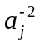, where c_{jj} is the j^{th} diagonal element of (X′X)⁻¹. The square root of this, 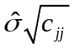/|a_{j}|, is se(), which is simply se()/|a_{j}|.

(vi) The t statistic for is, as usual,

/se() = (/a_{j})/[se()/|a_{j}|],

and so the absolute value is (||/|a_{j}|)/[se()/|a_{j}|] = ||/se(), which is just the absolute value of the t statistic for . If a_{j} > 0, the t statistics themselves are identical; if a_{j} < 0, the t statistics are simply opposite in sign.

E.4 (i)

(ii)

(iii) The vector of regression coefficients from the regression y on XG⁻¹ is

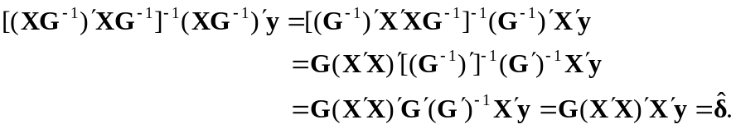

Further, as shown in Problem E.3, the residuals are the same as from the regression y on X, and so the error variance estimate, 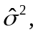 is the same. Therefore, the estimated variance matrix is

which is the proper estimate of the expression in part (ii).

(iv) It is easily seen by matrix multiplication that choosing

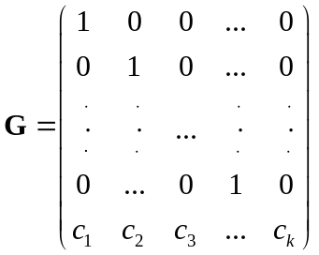

does the trick: if δ = Gβ then δ_{j} = β_{j}, j = 1,…,k−1, and 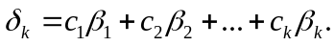

(v) Straightforward matrix multiplication shows that, for the suggested choice of G⁻¹, 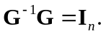 Also by multiplication, it is easy to see that, for each t,

E.5 (i) By plugging in for y, we can write

Now we use the fact that Z is a function of X to pull Z outside of the conditional expectation:

(ii) We start from the same representation in part (i): 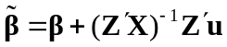 and so

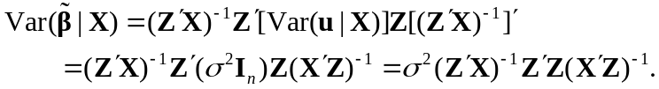

A common mistake is to forget to transpose the matrix 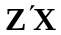 in the last term.

(iii) The estimator is linear in y and, as shown in part (i), it is unbiased (conditional on X). Because the Gauss-Markov assumptions hold, the OLS estimator, , is best linear unbiased. In particular, its variance-covariance matrix is “smaller” (in the matrix sense) than 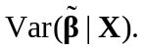 Therefore, we prefer the OLS estimator.

